INSTITUTIONAL PROGRAM REVIEW 2009-10
Program Efficacy Phase, Spring, 2010

Purpose of Institutional Program Review

Welcome to the Program Efficacy phase of the San Bernardino Valley College Program Review process. Program Review is a systematic process for evaluating programs and services annually. The major goal of the Program Review Committee is to evaluate the effectiveness of programs, and to make informed decisions about budget and other campus priorities.

The Institutional Program Review Committee is authorized by the Academic Senate to develop and monitor the college Program Review process, receive unit plans, utilize assessments as needed to evaluate programs, recommend program status to the college president, identify the need for faculty and instructional equipment, and interface with other college committees to ensure institutional priorities are met.

The purpose of Program Review is to:
❑ Provide a full examination of how effectively programs and services are meeting departmental, divisional, and institutional goals
❑ Aid in short-range planning and decision-making
❑ Improve performance, services, and programs
❑ Contribute to long-range planning
❑ Contribute information and recommendations to other college processes, as appropriate
❑ Serve as the campus’ conduit for decision-making by forwarding information to or requesting information from appropriate committees

Our Program Review process is two-fold. It includes an annual campus-wide needs assessment in the fall, and an in-depth review of each program every three years that we call the Program Efficacy phase. Instructional programs are evaluated the year after content review, and every three years thereafter, and other programs are placed on a three-year cycle by the appropriate Vice President.

An efficacy team of two disinterested committee members will meeting with you to carefully review and discuss your document. You will receive detailed feedback regarding the degree to which your program is perceived to meet institutional goals. The rubric that the team will use to evaluate your program is included with this e-mail

When you are writing your program evaluation, you may contact efficacy team assigned to review your department or your division representatives for feedback and input. The list of readers is being sent to you with these forms as a separate attachment.

Forms are due back to the Committee Chairs, Efficacy Team and Division Dean by March 22, 2010.
It is the writer’s responsibility to be sure the Committee receives the forms on time.

In response to campus wide feedback that program review be a more interactive process, the committee will pilot a program efficacy that includes a review team who will interviews and/or tour a program area during the efficacy process. Another campus concern focused on the duplication of information required for campus reports. The pilot will incorporate the Educational Master Plan One-Page Summary (EMP Summary) and strive to reduce duplication of information while maintaining a high quality efficacy process. More details on the pilot can be found in the attached file.

Program Efficacy, Spring 2010

Complete and attach this cover sheet as the first page of your report.

Program Being Evaluated
Economics

Name of Department:
Economics

Name of Division
Social Science, Human Development and Physical Education

Name of Person Preparing this Report Extension
Walt Chatfield

Name of Department Members Consulted
Walt Chatfield x8652.

Name of Efficacy Team
Teri Strong Ext. 8526; Paula Ferri-Milligan Ext. 8244

Program Review Committee Representatives
Sue Crebbin; Denise Knight

Work Flow | Due Date | Date Submitted
Date of initial meeting with department | 3-1-10 | 2-1-10
Final draft sent to the dean | 3-30-10 | 3-29-10
Report submitted to Program Review Team | 4-1-10 | 4-1-10
Meeting with Review Team

Staffing
List the number of full and part-time employees in your area.
Classification | Number Full-Time | Number Part-time, Contract | Number adjunct, short-term, hourly
Managers | 1 dean
Faculty | 2 |  | 2
Classified Staff | 2
Total | 5 |  | 2

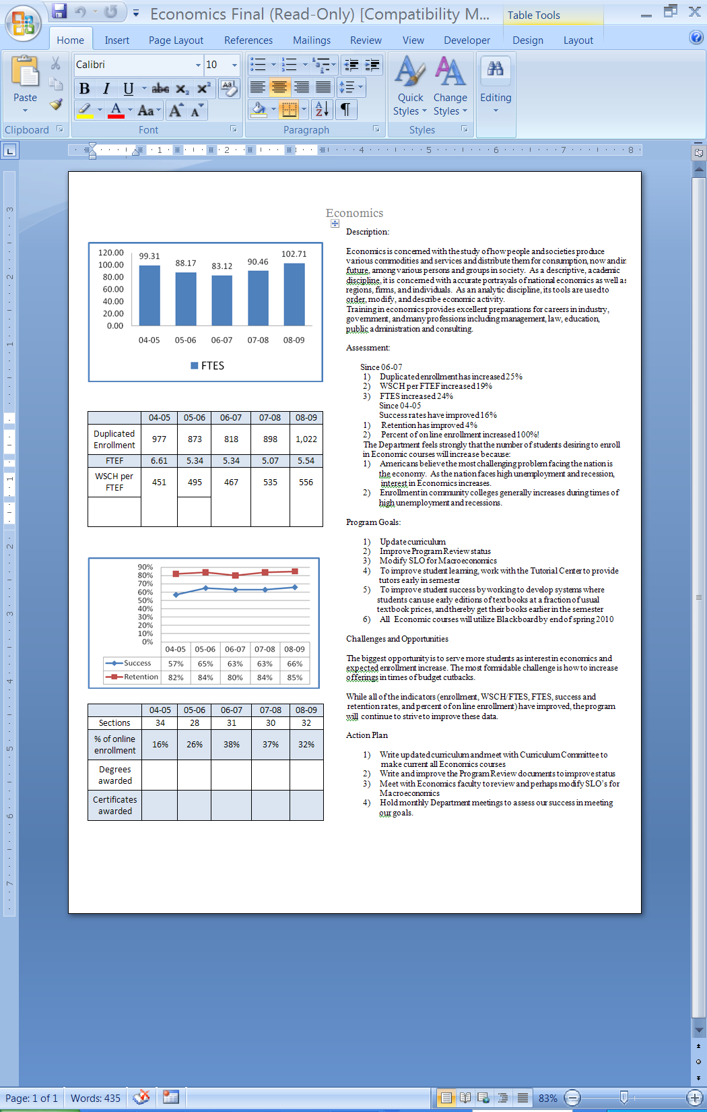
Part I. Questions Related to Strategic Initiative: Access

Use the demographic data provided to describe how well you are providing access to your program by answering the questions below.
Demographic Information
2004 - 2007
Gender (%) | Program Demographics | College Demographics
Male | 50.4% | 42.5%
Female | 49.4% | 57.5%
Ethnicity (%)
African-American | 25.6% | 22%
Caucasian (white) | 17% | 25%
Hispanic | 45% | 40%
Asian | 6% | 5%
Disability | 0.1% | 4.5%
Other

Economics
2008 – 2009

Gender | Frequency | Dept. Percent | Campus Pct.
Female | 1156 | 52.0 | 52.4
Male | 1058 | 47.6 | Not reported
Total count | 2225 | * | *

Ethnicity | Frequency | Dept. Pct. | Campus Pct.
Asian | 132 | 5.9% | 4.42%
Black | 528 | 23.7% | 20.50%
Filipino | 29 | 1.3% | 1.84%
Hispanic | 967 | 43.5% | 42.90%
Nat Amer | 12 | .5% | .93%
Other | 22 | 1.0% | .95%
Pac Islander | 28 | 1.3% | .72%
White | 417 | 18.7% | 22.48%
X-undeclared | 66 | 3.0% | 5.26%
Total | 2225 | * | *

Disability | Frequency | Dept. Percent | Campus Pct.
Non-Disabled | 2164 | 97.3% | 95.5%
Disabled | 61 | 2.7% | 4.5%
Total | 2225 | * | *

Average Age | N | Youngest | Oldest | Avg. Age Dept. | Avg. Age Campus
 | 2225 | 12 | 75 | 24.74 | 29.3

Does the program population reflect the college’s population? Is this an issue of concern? If not, why not? If so, what steps are you taking to address the issue?

Based on the three year data from 2004 to 2007, the Department of Economics has a higher percentage of males and a lower percentage of females than the College average. The Department plans to attend the annual Celebrating Women in Science Day meeting. The purpose of this meeting is to encourage young women to pursue careers that require strong backgrounds in Mathematics and/or science. Since Economics is a social science with strong mathematical foundations, this is a good place to encourage females into our program. This meeting takes place in the fall semester, usually in October. The Department will participate. We will contact Haragewen Kinde and get on the agenda.
While our percent of females appears low for our College, it does not appear low compared to our national statistics. Please see the table below. For our nation as a whole, the percent of females earning degrees in Economics ranges from approximately 30 to 40% (Source www.vanderbilt.edu/AEAdemo_info.htm)
Degrees Awarded 2005-2006 (Economics)
82 PhD Institutions 35 MA Institutions 158 BA Institutions
Total Percent female Total Percent female Total Percent Female

BA 11,955 31.8 1,466 29.3 3,782 34.1
MA 948 31.4 292 41.4
PhD 655 33.6

The Department has a lower percent of females as compared with the College, but it has a higher percent of females than the national average earning a degree in Economics.

Further the 04-07 data indicate the Department has a higher percentage of African-American students than the College (25.6% as compared with 22%), and a higher percentage of Hispanic (45% as compared with 40%). We are happy that minorities are interested in Economics, and the program staff plans to study the reasons for these differences. Of additional and complementary interest are the relatively low percentages of Caucasians (17% as compared with 25%). These data present an opportunity, which the program plans to study, to learn more about our students of Economics. The above source has data on a variety of demographic statistics concerning the Economics students of our nation.

It is a concern of this program that we have a relatively low percentage of students with disabilities. In addition the 04-07 data show we have just .1% as compared with 4.5% for the College. We are in the process of interviewing our students with disabilities to understand more about this issue and determine if there is a problem of access (or other issues) limiting enrollment of disabled students. It is a fact that many of our classes are held in upstairs rooms.

Examining more recent data from 2008 to 2009, the differences in the Department and the College basically disappear, indicating that there may be a natural variation in the data from year to year. For this time period, the College’s percent of females in virtually the same as the Department’s, 52.4% and 52% respectfully. In both time periods, the percent of disabled students is low for the Department.

It could be that the current data (08-09) is unusual and planning should be based upon data collected over a longer time period (04-07).

It is of interest that we serve younger students than the College. The average age of students in the Department is approximately 25 years old, while for the College it is approximately 29 years. This is probably due to the fact that Economics 100 is popular with the Middle College students. It is also promoted by our counselors encouraging Middle College students to enroll in Economics 100. It is not unusual for there to be 6-10 Middle College students enrolled in each section of this course. Our youngest student was 12 years old. Usually Economics students are slightly older than a college average. It should be noted that the average statistic is sensitive to extreme values, and not representative of the data when an extreme value is part of the average. “The mean (average) does have a weakness….If one or two of these values (the data) are extremely large or small compared to the majority of data, the mean might not be an appropriate average to represent the data.” Source, Basic Statistics for Business and Economics, fifth edition, Douglas A Lind, page 62. Since these data have extreme values (a few very young students), the average age of Economic students may not represent the whole group accurately.

As part of our monthly Department meetings, we will discuss ways to improve our recruitment of students and examine the data relevant to the program. In these meetings we will set goals, measure our success in attaining these goals, and if necessary reset goals measure success and continue to strive toward improvements.

Pattern of Service
How does the pattern of service and/or instruction provided by your department serve the needs of the community? Include as appropriate hours of operation/pattern of scheduling, alternate delivery methods, weekend instruction/service.

The Economics Department provides morning, afternoon, evening and weekend classes. We provide traditional lecture, online, and hybrid classes appropriate for the demand. Over the years there has been a consistent effort in the department to coordinate the Econ 200 (Macroeconomics) and Econ 201 (Microeconomics) in slots that do not conflict with other courses required for graduation for an A.A. degree in Business Administration. Courses such as Accounting and Business Law are routinely checked to ensure that students can put together a schedule of times that do not overlap. Checking the offerings of Econ 200 and Econ 201 few of our times overlap. Though it would be possible to fill two sections of Econ 200 or 201 at 8 am on Monday, Wednesday or Tuesday Thursday, the department instead has opted to run sections at later times to prevent overlap with Accounting classes. Both Accounting 200 and 201 are typically offered at 8 am.
In addition, we have had good success with late start classes—one for Econ 200 and one for Econ 201. Generally, students take Econ 208 class in the summer. This is the Business and Economics Statistics class which is required for graduation. This has always been offered in the Summer Program. This summer the class was cut because of budget issues. This action is particularly insensitive to many students who are taking the class in order to complete graduation requirements. We would like to see this class put back into the summer schedule. In addition, Summer offerings have been cut from 4 classes to 1 class comparing summer 2008 to summer 2010. The department has experimented with hybrid class offerings in Econ 200 and Econ 201. These classes have had much higher retention rates than the online courses—which do not have scheduled meetings on campus. The success rate of the hybrids suggests that we might experiment with the online class format to offer several sessions on campus at the beginning of the semester to see if this increases the retention rate for the online class sections.

A final consideration in scheduling involves the recent increase in the number of students enrolling in the Econ 200H Honors in Economics class. Previously, the economics program offered Honors Economics (Econ 200H) as a blended section with the Econ 200. However, the enrollments have been consistently rising semester after semester such that it may be possible to offer a stand-alone section of Econ 200H. This would definitely be the case if the overall enrollments in the Honors Program at Valley College continue to increase. This will be monitored closely in the future. Currently the blended section has registered 50 students in total for the last three semesters. The problem is that such large sections impact the quality of the instruction for the Honors students and the Econ 200 students as more students in the Honors sections do class presentations. This impacts the learning environment negatively as more Honors student presentations take up increasing amount of class time which would be devoted to teacher-led instruction. And with 50 students in the classroom it becomes difficult to address individual student needs.

Part II: Questions Related to Strategic Initiative: Student Success
Provide a brief analysis of the data and narrative from the program’s EMP Summary and discuss what it reveals about your program.
In the last few years, all of the Economic Department’s indicators have improved. Since 2006, Enrollment has improved 25%, WSCH per FTEF (19%), FTES (24%). Since 2004, Success Rates have improved 16%, Retention (4%), and Percentage of on-line enrollment (100%). This reveals that the program is growing and providing a needed service to our community. Implications are that we are successful and should continue to strive to improve our program and offerings as we have done in the past.

Supplemental Data
Provide any additional information such as job market indicators, standards in the field or licensure rates that would help the committee to better understand how your program contributes to the success of your students.
Economics is a requirement of programs in the business area. Both Economics 200 and 201 are a requirement for an AA degree in Business Administration. There were 25 degrees given in 06-07. Also both Macroeconomics and Microeconomics and required for an Accounting Certificate. Economics 100 is required for a Business Administration Certificate. In the spring of 2009 there were three certificates awarded in Accounting and Business Administration.
Graduates in Economics do well in business, government, research and education. While Economics majors are not in the top ten highest starting salaries, they score in the top ten (actually fifth) highest mid career salaries at $101,000 per year. (source, http://channels.com/pf/package.jsp?name=fte/profitablemajors/profitablemajors) These data suggest that the economic “way of thinking” provides useful knowledge that promotes success, as measured by high earnings, for Economic majors. These high salaries also suggest that the services of economists are valued by society.

Student Learning Outcomes
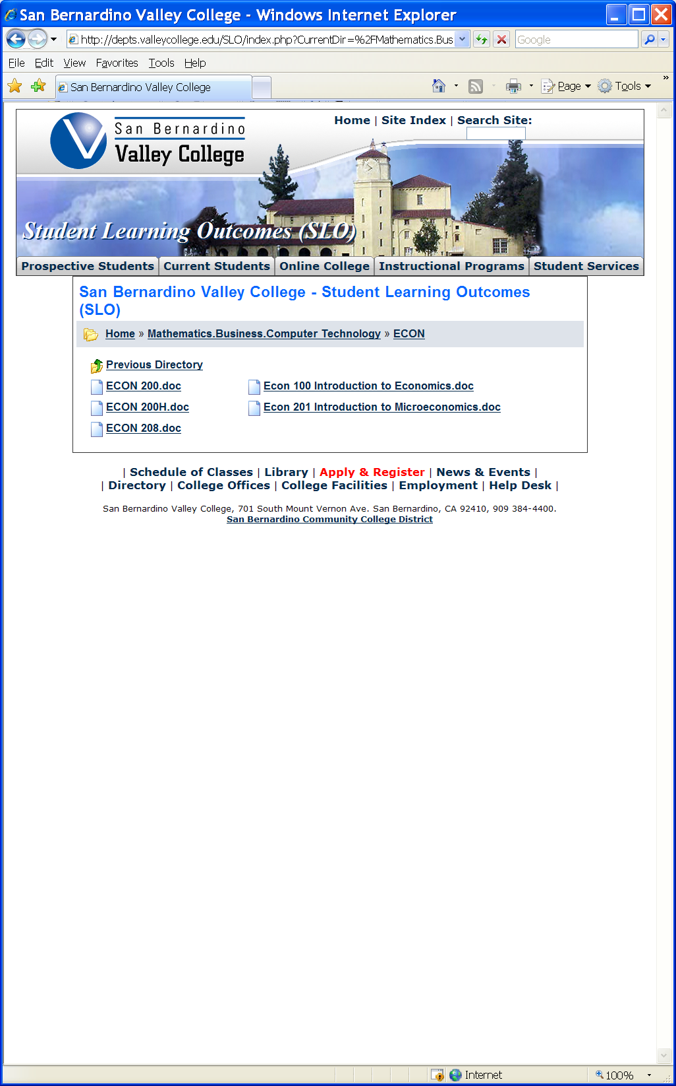
The list above shows the courses that have SLOs on file with the Office of Instruction.

If you have courses for which SLOs have not been developed, explain why. What are your plans to remedy this?
SLOs have been developed for all the Economics courses.

Attach your three-year plan for assessing SLOs.

(See plan below)

What progress has the program made in its three-year plan? Have you implemented any program changes based on assessment results?

At the time the plan was developed, Economics was in a department with Accounting, Business Calculations, Paralegal and Real Estate/ Escrow. Since then, Economics was moved to the Social Science Division and is a department by itself. Fortunately for Economics, the original plan was to do Economics first and then progress to the other programs. Consequently, Economics has moved further along than originally planned. Our accomplishments are:
- All SLO’s have been developed
- All SLO’s have been assessed
- As a result of this assessment, two SLO’s were rewritten
- All SLO’s have been entered into elumen
- The rubrics are about one half complete and the only remaining component is to finish this elumen work. It is planned to complete all of this work by the end of fall 2010.

Department: Accounting, Economics, Business Calculations, Paralegal, Real Estate/ Escrow
Course | Assessed FA08 | Assessed SP09 | Semester to be Assessed

ECONOMICS

Econ 100 Will be assessed at time of finals SP09.
Econ 200 Will be assessed at time of finals SP09.
Econ 200 H Will be assessed at time of finals SP09.
Econ 201 Will be assessed at time of finals SP09.
Econ 208 Will be assessed at time of finals SP09.

BUSINESS CALCULATIONS

BUSCAL 050 Assessment tools will be developed FA 09, and assessed SP10.
BUSCAL 091 Assessment tools will be developed FA 09, and assessed SP10.
BUSCAL 200 Assessment tools will be developed FA 09, and assessed when class is offered.
BUSCAL 208 Will be assessed at time of finals SP09.

ACCOUNTING

ACCOUNTING 010,030,047,090,100,101,132,200,201,206,235,236,and 237

Assessment tools will be developed for these accounting classes in the FA09, and assessment will take place in SP10, or the next semester the class is offered.

PARALEGAL

PARLGL 110, 200, and 205
Assessment tools will be developed FA 09 and assessed in SP10.
PARLGL 100,111,120,130,220,230, and 240
Assessment tools will be developed SP10 and assessed when classes are offered.

REAL ESTATE / ESCROW

RE 100,200,220 901 and 902
These will be assessed at time of finals SP09.
RE 101,102,102,205,210,211,215,220, and 230
These will be assessed the next time they are offered.
ESCROW 101,102, and 103
These will be assessed the next time they are offered.

Part III. Questions Related to Strategic Initiative: Institutional Effectiveness
Mission and Purpose
What is the purpose of the program?

The Economics Department provides quality instruction to a diverse population of learners in Principles of Economics and Economic survey courses, covering both macroeconomics and microeconomics. Economics is a “way of thinking” rather than a set of facts. Therefore, the focus of the program is to develop our diverse students’ ability to utilize the discipline’s unique analytic tools in order to be better decision-makers in their individual environments. Successful economics students will have the skills to make better and more informed decisions about public and personal issues.

How does this purpose relate to the college mission?

The mission of our College, (“San Bernardino Valley College provides quality education and services that support a diverse community of learners.”) and the purpose of the Economics Department are very similar. They both emphasize quality education and diversity of our students.

Productivity
Provide additional analysis and explanation of the productivity data and narrative in the EMP Summary, if needed.
The Economics Department has consistently scored higher than the campus average in all measures of productivity.
7 Year Campus Average Economics 08-09 Difference
WSCH/FTEF 447 556 109
Success 62% 66% 4%
Retention 66% 85% 19%
While the Department has been successful in the area of productivity, Economics will continue to strive to improve these numbers. We plan to put tutors in place soon in the semester (by finding tutors in one semester for the next coming semester), select affordable texts (by exploring many options and selecting the best one, options are online books, eBooks, using older editions, renting books, etc), provide quality instruction (by keeping current with profession, attending seminars and workshops) and improve our use of technology in the class room (by participating in training in technology, keeping current).

Relevance and Currency, Articulation of Curriculum
If applicable to your area, describe your curriculum by answering the following questions.
Social Sciences, Human Development & Physical Education
Economics
 | Course | Status | Last Content Review | Next Review Date
 | ECON100 Introduction to Economics | Active | 04/15/2004 | 04/15/2010
 | ECON100 Introduction to Economics | Launched | 03/29/2010 | 03/29/2016
 | ECON200 Principles of Macroeconomics | Launched | 11/15/2002 | 11/15/2008
 | ECON200 Introduction to Macroeconomics | Active | 11/15/2002 | 11/15/2008
 | ECON200H Introduction to Macroeconomics - Honors | Active | 11/15/2002 | 11/15/2008
 | ECON200H Principles of Macroeconomics - Honors | Historical | 11/15/2000 | 11/15/2006
 | ECON200H Principles of Macroeconomics - Honors | Launched | 11/15/2002 | 11/15/2008
 | ECON201 Principles of Microeconomics | Launched | 04/15/2004 | 04/15/2010
 | ECON201 Principles of Microeconomics | Active | 04/15/2004 | 04/15/2010
 | ECON208 Business and Economics Statistics | Active | 04/27/2009 | 04/27/2015
 | ECON208 Business and Economics Statistics | Historical | 04/15/2000 | 04/15/2006
 | ECON222 Independent Study in Economics | Active | 04/15/2004 | 04/15/2010
 | ECON285 Honors in Economics | Historical | 04/27/2009 | 04/27/2015

The Content Review Summary from Curricunet indicates the programs current curriculum status. If curriculum is out of date, explain the circumstances surrounding the error and plans to remedy the discrepancy.
The first item of our Action Plan in the EMP is to write and update curriculum to make current all Economics courses. We are happy to report that good progress has been made:
- Economics 100 has been updated and approved by the Curriculum Committee on 3-29-10.
- Economics 200, 200H and 201 have been launched and are scheduled for technical review by the Curriculum Committee on Monday April 5.
- Our proposed new course Economics 201H (Honors in Microeconomics) is to be launched this month. This is part of our plan to get all of our courses articulated with all CSU and UC campuses. See below.

Articulation
List Courses above 100 where articulation is not occurring | With CSU | With UC
None

Describe your plan to articulate these classes.
All of our courses transfer for credit to both CSU and UC with the exception of CSU Long Beach and SDSU, San Diego. These institutions require a Mathematics prerequisite to transfer for credit. The Department has started work to develop the curriculum to include Math 095 as a prerequisite in both Economics 200H, and to be developed Economics 201H (Honors in Microeconomics). Economics 201H will be launched this month. With this in place, students who wish to transfer to these institutions could take the Honors classes. We will monitor progress in this area in our monthly Department meetings. It is a top priority of the Economics Department to articulate all of our courses with all CSU and UC institutions.

Currency
Review the last college catalogue data given below.

Which courses are no longer being offered? (Include Course # and Title of the Course)

All of our courses are offered each semester. Typically there are 3 sections of Econ 100, 5 sections of Econ 200, 4 sections of Econ 201, and just 1 section of Econ 208 and Econ 222.

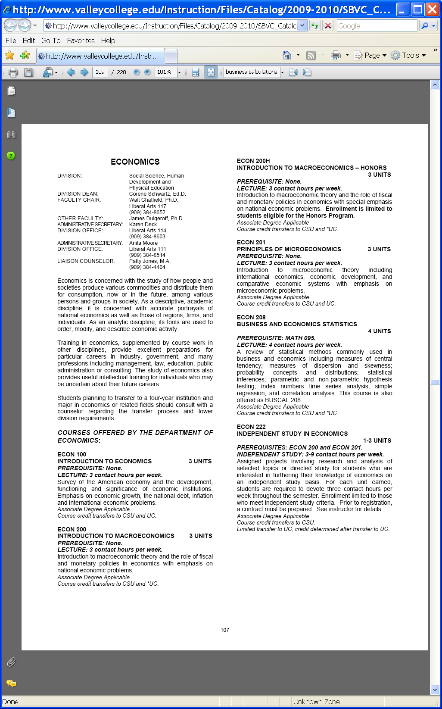

Planning
What are the trends, external to the institution, impacting your student enrollment/service utilization? How will these trends impact program planning?
This Department feels strongly that two external trends will increase interest and potential enrollment in Economic courses.
- Most Americans believe the current state of the economy is the nation’s most significant problem. As the nation faces high unemployment and recession, the interest in Economics increases. This is supported in the EMP data. For the time 07-08 to 08-09, FTES increased from 90.46 to 102.71.
- Enrollment in community colleges typically increases during times of high unemployment and recession. This is evidenced by a report from the California Community College Chancellor’s Office dated 9/2/2009 which states “Community Colleges have seen a 15.9 percent increase in headcount in the last four years.”
(http://www.cccco.edu/Portals/4/News/press_releases/2009/Enrollment_Surge_CCCs_%20Duncan_Release_9-3-09.pdf)
The Department plans to encourage the College to offer more sections in Economics. All our sections closed early in the registration process and it is obvious that more sections could have filled. We believe it is in the best interest of the College to open more sections. Persuading our administration, with their growing budget challenges, will be difficult.

Accomplishments and Strengths
Referencing the narratives in the EMP Summary, provide any additional data or new information regarding the accomplishments of the program, if applicable. In what way does your planning address accomplishments and strengths in the program?

The Department of Economics accomplishments and strengths are:
- Higher than the College average success rates
- Higher than the College average retention rates
- Higher than the College average WSCH/FTEF rates
- Increasing FTES
These strengths and accomplishments will be supported by our plans to:
- Provide tutors early in the semester to improve learning. We plan to accomplish this by encouraging our tutors to continue from semester to semester (finding them earlier in their academic career) and by recruiting tutors from the Honors Program and specifically from our Economics 200 Honors class.
- Select appropriate and affordable texts. We plan to accomplish this by working with publishers and selecting the best choice for our students. We plan to explore the possibilities of using on-line texts. Also we will continue to work with students and show them how to meet the objectives of the text with an older (and far less expensive) edition.
- Provide quality instruction. The faculty in this department plan to attend workshops and seminars to improve our teaching skills. It is planned to attend the Great Teacher’s Seminar (scheduled for the first week of August this year) and others skill promoting seminars and workshops.
- Utilize the latest technology in instruction. We currently offer on-line and hybrid courses, but in addition, we plan to get the remaining courses (Economics 100) on BlackBoard by the end of this semester. We will continue to employ the best technological support we can.

Weaknesses
Referencing the narratives in the EMP Summary, provide any additional data or new information regarding planning for the program. In what way does your planning address trends and weaknesses in the program?
The most significant weakness of the program is the inability to serve all of the students desiring to enroll in an Economics course. We are planning to address this in two ways:
- The Department will encourage the College to offer more Economic sections. This is admittedly difficult given the current budget constraints of our state. Nevertheless, every effort will be made to promote the benefits of Economics to our community and persuade administration to offer more sections. This semester dozens of students were turned away for lack of sections.
- The faculty will be more diligent in managing the adds and drops at the beginning of the semester so the maximum number of students can be served. Roll will be called in each of the classes, and students who are not attending will be replaced with those who are present and willing to take the class. This will increase enrollment with those who are more likely to be successful.

V. Questions Related to Strategic Initiative: Technology, Campus Climate and Partnerships.

Describe how your program has addressed the strategic initiatives of technology, campus climate and/or partnerships.
TECHNOLOGY
Each semester the Department offers hybrid and online classes in Economics 200 and 201. In the majority of Economics classes offered, students are instructed in the use of the Blackboard Course Management System (CMS). The exception to this is our Economics 100 classes. We are working this semester to get this course on blackboard, and have a goal to complete this before the end of this semester. Work is currently about one half complete. For our Economics 200 and 210 classes, students cover materials online, including videos on the current fiscal crisis and plans for fiscal stimulus. This material is not in the textbook. When the federal reserve starts opening up the discount window to investment banks on Wall Street, we can broadcast the news clips to our students, much before they can include this material in the textbook. This technology is invaluable for keeping up with the monetary policy in Macroeconomics. Most sections of Economics 200 and 201 have active Blackboard CMS components. The Department has plans to encourage part time faculty (on the agenda of our next Department meeting) to attend workshops as they are offered on campus and to use this technology. In most sections discussion boards are used. In addition to the traditional tools of video and discussion board material, students in the Honors Economics 200h are required to produce PowerPoint presentations and use a multi-media format to deliver talking points during student presentations. Also, students are required to use the library’s online SIRS and EBSCO host systems to produce and annotated bibliography of their research, and the online resources are checked for accuracy.
PARTNERSHIPS
The Economics program is linked to the College Honors program. We offer Economics 200H every semester, and we are planning to develop Economics 201H (Honors in Microeconomics). This new course will be launched this month.
Economics is also linked to the Business Administration Major for an AA degree, both Economics 200 and 201 are required. There were 25 degrees given in 06-07. We are linked to the Accounting Department. Both Economics 200 and 201 are required for an AA in Accounting and an Accounting Certificate. We are also linked to the Business Administration Certificate; Economics 100 is a requirement for this certificate. There were three certificates awarded in Accounting and Business Administration in spring 2009.

